OldWorldSocks.com

RETURN FORM
for return of non-defective, correctly packaged merchandise

If you are dissatisfied with your purchase, you may return it to us within 30 days from invoice date
Socks must be returned in new, unworn, untried, re-sellable condition, and in the original, intact packaging
Any returned merchandise is subject to review by oldworldsocks.com

In order for us to process your return quickly and accurately,
please read carefully our return policy at www.oldworldsocks.com/return policy and follow instructions
You can also download and print this form there

If you received wrongly packaged or defective socks, do not use this form! 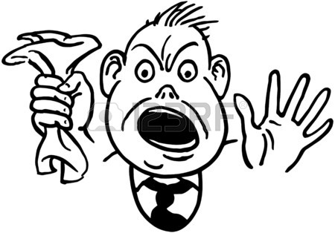
You should use

MERCHANT ERROR/DEFECTIVE MERCHANDISE EXCHANGE FORM

You can find Merchant Error/Defective Merchandise Exchange form and instructions
at www.oldworldsocks.com/return policy

Please fill out all information to ensure prompt and accurate refund. Refund will be issued to the original form of payment
order number | name
address
city state zip code
phone email

ITEMS BEING RETURNED
style | size | color | quantity | reasons for return

This form must be signed for your return to be processed
Please sign here to confirm that you have read, understand, and accept our terms/conditions

x…………………………………………………………. Date…………………………….

Please mail your returns to:
Old World Socks Returns Dept
2020 Maple Hill Street Unit 282
Yorktown Heights NY 10598

